**BREAST MASS SEGMENTATION ON DIGITAL MAMMOGRAMS BY A COMBINED DETERMINISTIC ANNEALING METHOD**

**ABSTRACT**

In this paper, we developed one breast mass segmentation scheme which is based on the concept of **deterministic annealing (DA) and incorporated with a gain adaptive contrast enhancement (GACE) preprocessing technique.** The probability distribution of gray levels within the region of interest(ROI) after GACE filter are estimated and a series of image partitions are obtained according to the intensity proximity as the temperature decreases. Compared with **the segmentation results of DA without enhancement, and DA with histogram enhancement, the experimental results show that the combined DA and GACE segmentation scheme works more efficiently.**

**INTRODUCTION**

There are two major groups of the clinical objectives: detection of calcification cluster and detection

of masses. The detection of masses is relatively more challenging **since masses are often embedded in breast tissues and indistinguishable from the surrounding parenchymal tissues** [1]. The two major stages of digital mammographic mass detection are **segmentation and classification,** where the performance of the second stage is highly depends on the first stage. N.Petrick et al. proposed an **adaptive density-weighted contrast enhancement (DWCE) filter for masses detection** [2]. R.M.Rangayyan et al [3], H.Kobatake et al. [4], Huai Li et al. [5] and L.Zheng et al. [6] all proposed relative algorithms to segment and detect breast masses. While it is very hard to compared the performance of these algorithms due to they are subtle to different database. In this study, we present a mass-constrained clustering approach based on DA [7] for segmentation of breast mass on digital mammograms, as a means to provide an efficient and quality measure for the accuracy of breast mass detection**. A GACE filter is proposed as an image preprocessing technique for image enhancement. We segment the suspicious mass within the ROI, which has been selected according to the information provided by the image database. As an implementation of this method, segmentation results on images from MIAS2 database are presented.**

**MASS-CONSTRAINED DETERMINISTIC ANNEALING**

The ROI normally contains subregions of fat, parenchymal tissues and masses. Each region correspond to one **group of intensity level.** Although the mean intensity of each group should be different, where the mean intensity of **fat tissue is lowest and the mean intensity of the mass tissue is the highest**. While the mean intensity of each group maybe vary according to their surrounding tissues. Under some condition, the **mean intensity of** **parenchymal is higher than the mean intensity of the mass region in a same mammogram**. The proposed method **to segment mass region is based on the assumption assume that the mean intensity of mass region is brighter than its surrounding tissues.** Then there will be three classes for a region based method: **fat region and mass or parenchymal region**. Image segmentation requires that a decision be made **about the type of a pixel, i.e. which intensity groups it belongs to.** It is an observation at each pixel and describes the relation between feature vectors and pattern classes, which can also be stated as partitioning a given set of pixels into subgroups, each of which should be as homogeneous as possible within group, **and should be as inhomogeneous as possible between groups**. Mathematically speaking, **it is an unsupervised clustering problem**. The clustering problem is formulated as an important optimization problem by defining a cost criterion to be minimized. It is a **non-convex optimization problem since the useful criterion functions are not convex but riddled with poor local minima, which is a problem encountered by fuzzy c-means.** DA adopts information theory and a deterministic relaxation method that is a **global convergence optimization process**. In this way, DA provides an excellent tool for blending the information of each pixels in an image into a global framework and decides each pixel’s label that represent different pattern groups. A brief illustration of clustering method in image segmentation is shown in figure 1.

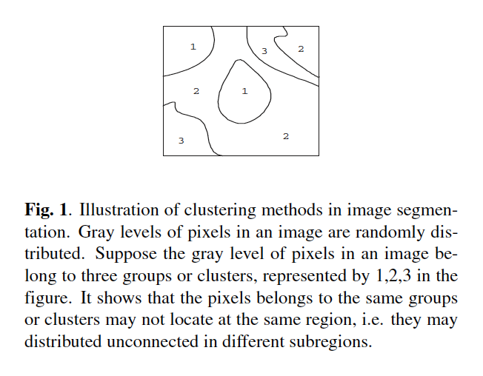

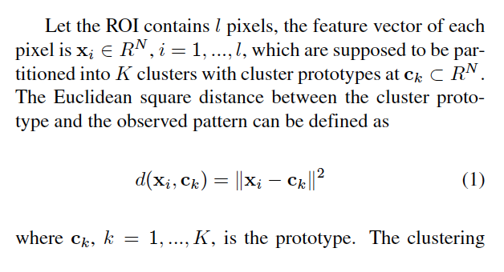 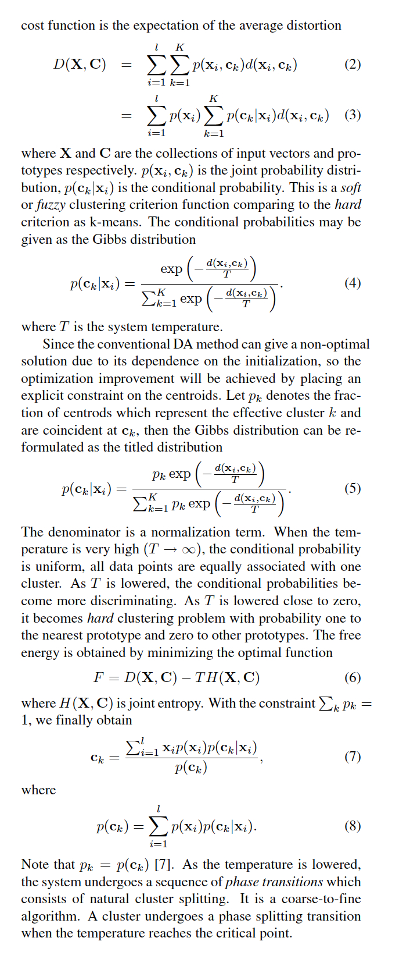

**GAIN ADAPTIVE CONTRAST ENHANCEMENT**

Although the **intensity of mass region is relative high and brighter than its surrounding background, while it is still a challenging and hard task to detect mass due to the complicated background structure and low contrast of the mammographic image, particularly the signal-to-noise is pretty low around the boundary of mass region**. As a help of improving the masses segmentation performance, we propose an **gain adaptive contrast enhancement (GACE) technique to preprocess the image before DA segmentation.**

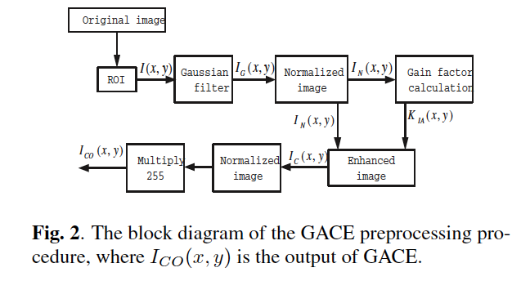

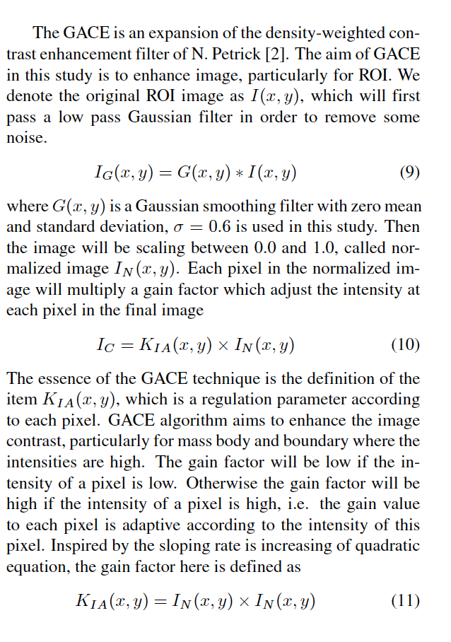

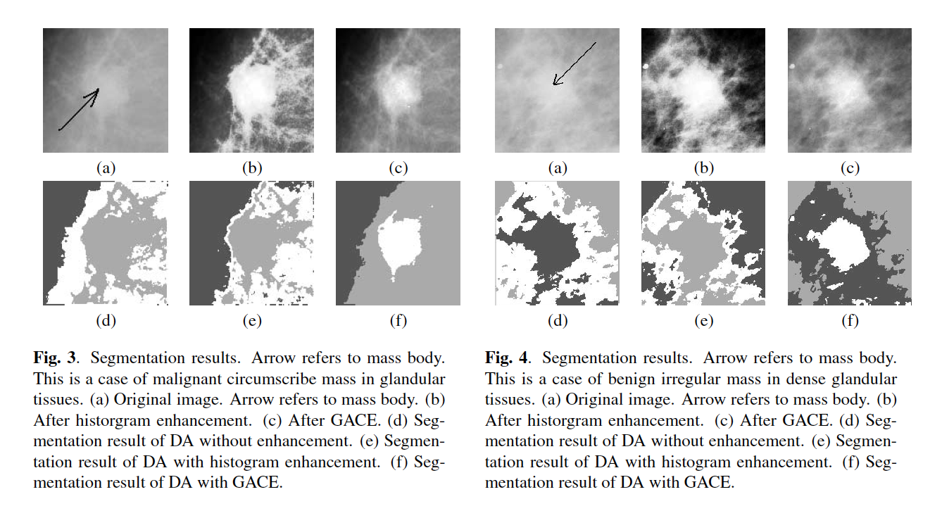

**Proposed a segmentation scheme of incorporating mass constrained DA and GACE filter for breast masses on digital mammographic images. Compared the segmentation results of DA algorithm with and without histogram enhancement, the proposed segmentation scheme works more efficiently and reduces noise significantly, which will decrease computation complication for later detection steps and increase the final detection performance**